Geologic computing Hw 5
Steven Rizo

Problem 1:
Use the Proj.4 Cartographic Library to convert a file from UTM coordinates to WGS84 lat-long coordinates.

Command Line:
proj -I +proj=utm +ellips=WGS84 +zone=10 -f "%.6f" filtered_crater_lake_data.xyz > longlat_crater_lake.dat

Output:
-122.162385 42.930254 1882.00
-122.162363 42.931875 1882.00

Problem 2:
Make a location map for Crater Lake using pscoast that has sufficient area to locate the volcano relative to its location in the US. This map should also include a plotted and labeled location marker for the volcano as well as labels for the states and large bodies of water.

Location Map:
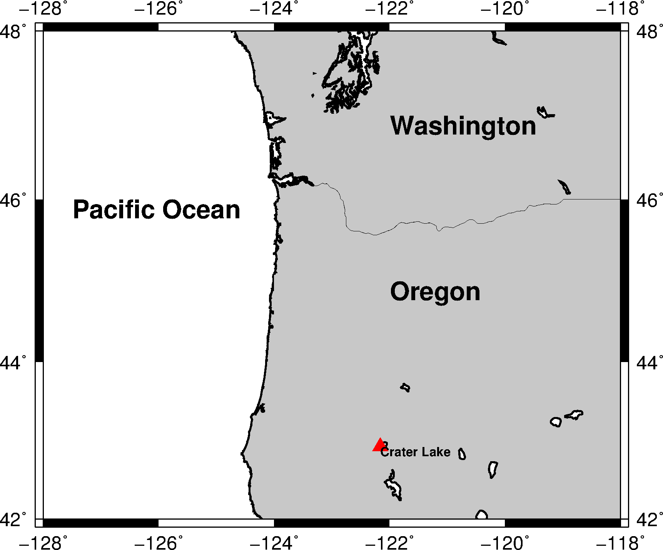
Figure Caption: Coastal map showing the location of the Crater Lake caldera within the state of Oregon in the US. The labeled red triangle shows the location of this caldera.

Command Lines:
gmt pscoast -JM5i -R-128/-118/42/48 -Df -N1 -N2 -W1p -G200 -Ba2 -BNSEW -V -K > pscoast_crater_lake.eps
gmt psxy cl_location.dat -J -R -St0.4c -Gred -V -O -K >> pscoast_crater_lake.eps
gmt pstext cl_location.dat -J -R -F+f8p,1,0+a0,+jLT -V -O -K >> pscoast_crater_lake.eps
gmt pstext txt_location.dat -J -R -F+f16p,1,0+a0,+jLT -V -O >> pscoast_crater_lake.eps
gmt psconvert pscoast_crater_lake.eps -A -P -Tg -V

pscoast:
-J sets the parameters for the map projection with -JM5i using an equal-area Mercator projection with a map size of 5 inches
-R specifies the region of interest or map boundaries in a west/east/south/north order
-D selects the resolution with -Df being the full resolution available
-N draws political boundaries with -N1 being national boundaries and -N2 being state boundaries
-W draws shorelines with -W1p drawing all shorelines with 1 point of thickness
-G in pscoast fills in the color of inland areas with -G200 being a greyscale fill
-B formats the plotting of axes with -BNSEW maening that all axes are plotted and labeled and -Ba2 defining the tick spacing of 2 degrees
-V selects verbose level with the -V default being progress and warning messages
-K informs gmt that more postscript will be added later
-O informs gmt that the information is being overlayed

psxy:
-S plots a symbol with -St0.4c being a triangle that fits within a 0.4 diameter circle
-G fills the color of the symbol with -Gred making the color red

pstext:
-F formats the text
+f controls the font with +f8p being 8 point font
+a sets the angle
+j sets the justfication

psconvert:
-A adjust the boundary box to the minimum required by image content
-P forces portrait mode
-T seets format with -Tg being for png output

